# Cookie cutter How to initialize a new project?

To initilazize a new project , go to directory where initial json file is there then run co mmand “**cookiecutter .** “ where dot represent current directory

User name: access goven to some other person who has access to the deployed workflow , and dependent files

datbrick.yml= it has all the hosts for all test and prod environments also it has username permissions for individual environments. It includes workflow files(resources/sbx/*.yml) that needs to be deployed. And we are making an mlflow experiment

Resources will have all the yml file related to workflow for all test and prd environments

It will have batch_prediction yml file which will do only the prediction of data and it will have mlops_classification_framework which will have all the steps of the workflows(eg ingestion, training,prediction) . usually we rubn the workflow of mlops_classification_framework the first time and upon when the training is done we can use the batch prediction workflow.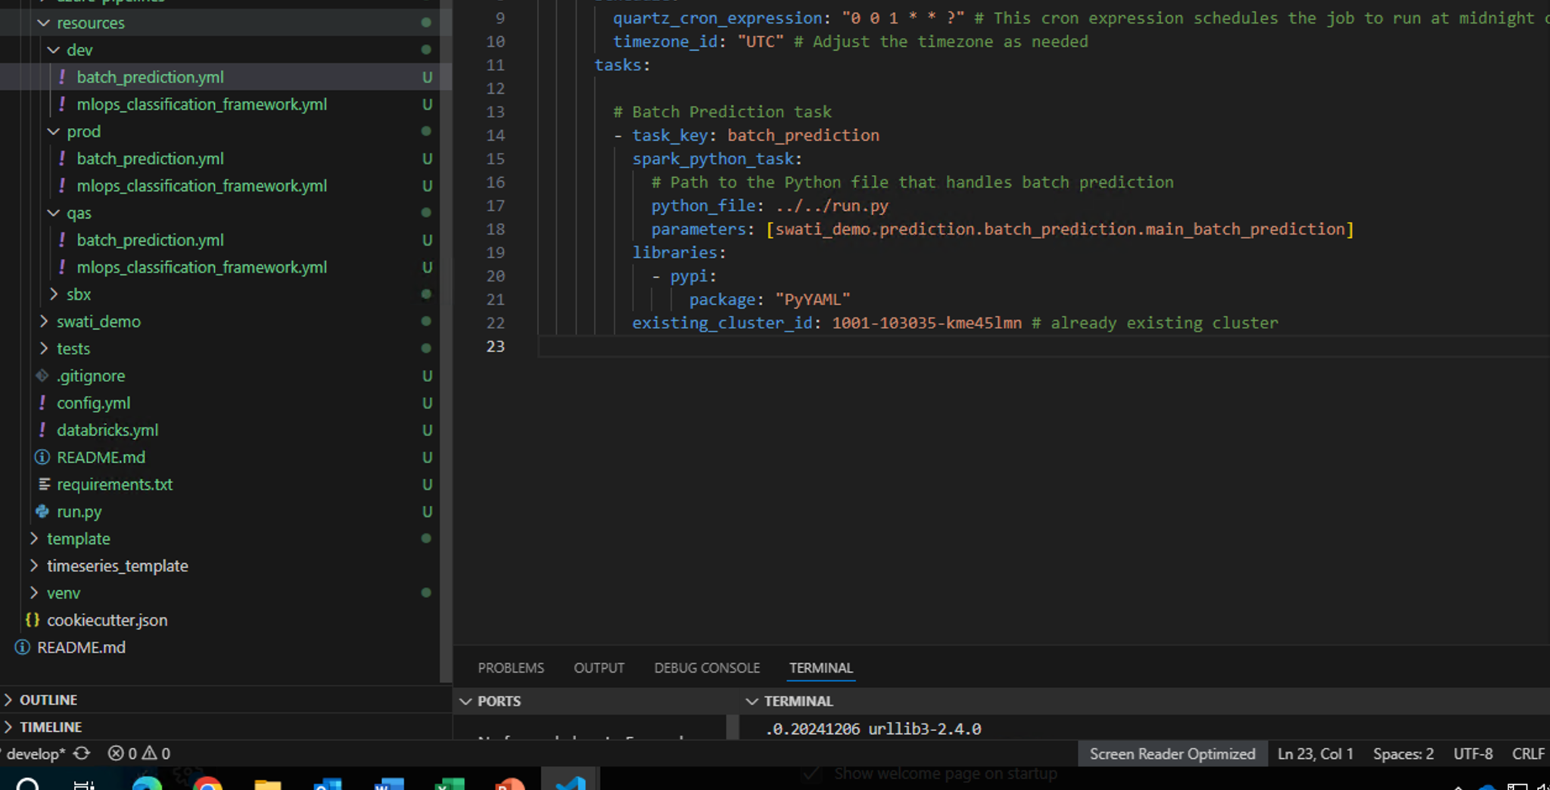

Azure pipeline: it updates the library with help of (update_libs.py) python script. It picks up libraries from requirement .txt and then runs it in resources workflow under dependent libraries.

And it assigns the right env according to the branching name,based on the env it will do the necessary change which involvews changing the include parameter of databrick.yml according to the env chossen and other env specofc configuration like table name catalogue name,path.